

YEAR 12 GENERAL HUMAN BIOLOGY

Task 6: Endocrine Systems Test

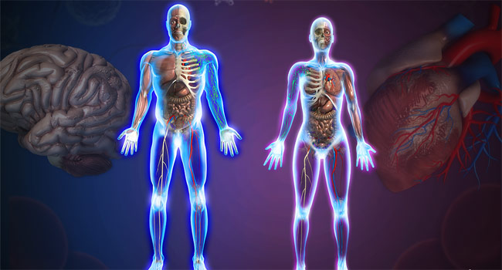

-DO NOT MARK THIS BOOKLET-

Multiple Choice: 10 marks

Short Answer: 25 marks

**TOTAL 35 MARKS**

**Section A: Multiple Choice (15 Marks)**

Answer all questions by placing and X through the most correct answer on the multiple choice answer sheet.

1 The endocrine system:   
a) releases chemicals into the bloodstream for distribution throughout the body   
b) releases hormones that alter the metabolic activities of many different tissues and organs   
c) produces effects that can last for hours, days, or even longer   
d) all of the above

2 Which of the following characteristics is the same for the nervous and endocrine systems:  
a) target cells affected  
b) time to onset of actions  
c) duration of actions

d) none of the above

3 Which of the following would result from a thyroidectomy (removal of the thyroid gland)?

1. decreased TSH secretion
2. increased T3 and thyroxine secretion
3. increased calcitonin secretion
4. increased TSH secretion

4 Which of the following is true regarding hormones and nerve impulses?

1. hormones produce quicker longer lasting responses
2. nerve impulses produce quicker longer lasting responses
3. hormones produce quicker shorter lived responses
4. hormones produce slower longer lasting responses

5 Hormones enter cells directly from the

1. blood.
2. exocrine glands.
3. endocrine glands.
4. extracellular fluid.



Using the information in the above diagram

6 Which of the following lists labels correctly the structures of the endocrine system shown in the diagram?

a) A = pituitary gland, F = pancreas, E = adrenal glands

b) B = pituitary gland, D = parathyroid glands, F = pancreas

c) C = parathyroid glands, E = pancreas, G = ovaries

d) A = pituitary gland, D = thyroid gland, E = pancreas

7 One of the hormones produced from the structure labelled ‘E’ is?

a) insulin

b) progesterone

c) adrenalin

d) growth hormone

8 The adrenal gland secretes both

(a) adrenocorticotrophic hormone and cortisol

(b) adrenaline and luteinising hormone

(c) noradrenaline and oestrogen

(d) adrenalin and cortisol

9 The pancreatic hormone that cause glycogen to be converted into glucose is

a) insulin

b) calcitonin

c) thyroxine

d) glucagon

10. Adrenalin is produced in the

a) adrenal medulla

b) adrenal cortex

c) anterior lobe of the pituitary

d) posterior lobe of the pituitary

**PART B: Short Answer Section (25 marks)**

**Question 11 (5 marks)**

a Name the three endocrine glands found in the brain:

1. ___________________________________________________
2. ___________________________________________________
3. ___________________________________________________

b Write the appropriate term for each of the following phases

i) The ‘master’ gland.

_____________________________________________

ii) The part of the brain that connects nerves and hormones.

_____________________________________________

**Question 12. [10 marks]**

Describe the 5 common features of steady state control systems.

________________________________________________________________________________________________________________________________________________________________________________________________________________________________________________________________________________________________________________________________________________________________________________________________________________________________________________________________________________________________________________________________________________________________________________________________________________________________________________________________________________________________________________________________________________________________________________________________________________________________________________________________________________________________________________

**Question 13 (10 marks)**

An investigation was carried out into the effects of administering the hormone thyroxine to

patients with a malfunction of the thyroid gland. Two groups of patients were treated; Group A

received the hormone and Group B received a placebo. The basal metabolic rate (BMR) of the

patients in the two groups was taken over a period of three weeks. All patients in both groups began with a similar BMR which averaged 30% below normal. After three weeks, patients in Group A had raised their BMR on average to 1% below normal. Group B still had an average BMR of 30% below normal.

1. Suggest an hypothesis this experiment was designed to test. (2 mark)

________________________________________________________________________________________________________________________________________________________________________________________________________________________________________________

(b) (i) Name the condition these patients were suffering from. (1 mark)

________________________________________________________________________________________________________________________________________________________________

(ii) State **two** symptoms, apart from low BMR, that they would be displaying before

treatment. (2 marks)

________________________________________________________________________________________________________________________________________________________________________________________________________________________________________________

(c) To maintain thyroid function and a normal BMR, a series of events must take place

involving the thyroid gland and its interaction with two other structures in the body.

Using a steady state control system describe the series of events involving the thyroid gland and these two other structures that would occur to prevent a healthy person’s BMR from dropping to below normal levels. (5 marks)

________________________________________________________________________________________________________________________________________________________________________________________________________________________________________________________________________________________________________________________________________________________________________________________________________________________________________________________________________________________________________________________________________________________________________________________________________________________________________________________________________________________________________________________________________________________________________________________________________________________________________________________________________________________________________________

**YEAR 12 GTHBY HUMAN BIOLOGY**

Task : Endocrine Systems Test

SCORES:

MC: /10

SA: /25

TOTAL: /35

_______ %

**NAME:_____________________________**

**TEACHER:__________________________**

**DATE:______________________________**

**Section A: Multiple choice (10 Marks)**

Answer all questions by circling the most correct answer on the multiple choice answer sheet.

1. a b c d 13. a b c d

2. a b c d 14. a b c d

3. a b c d 15. a b c d

4. a b c d

5. a b c d

6. a b c d

7. a b c d

8. a b c d

9. a b c d

10. a b c d

11. a b c d

12. a b c d